

Date: _________________

Dear

[I am/we are] writing to you regarding the delivery of non-contractual work. Because this activity is outside [my/our] standard contract, separate arrangements will therefore need to be agreed for it.
While [I am/we are] willing to undertake this work, [I am/we are] only prepared to do so for a rate that appropriately reflects the value of [my/our] time.

As such, this letter is to notify you that with effect from ______________________
[I am/we are] only willing to deliver this activity if it is remunerated at the value set out on the BMA rate card as a [cash value/PA value] or better. This rate card is included as an annex to this letter.

[I/we] would be grateful if you could confirm your acceptance of this rate prior to any such additional work being undertaken.

Any request to deliver on-call activity that requires consultants to be resident overnight will be subject to a separate special agreement and additional rates.

Yours sincerely,

Annex 1

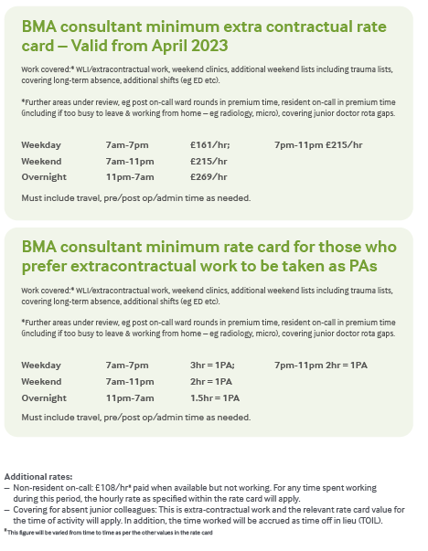
w

